Warning system scores first major earthquake alert in Yunnan
Global Times | 2013-2-20 23:43:02
By Xu Tianran

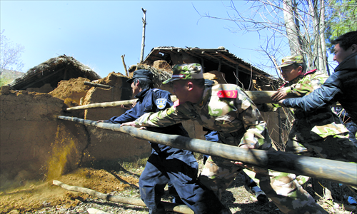
Rescuers help local villagers in Qiaojia, Yunnan Province to dismantle damaged walls after an earthquake on Tuesday to avoid future risk. Photo: CFP
China's earthquake authority has successfully sent warnings against a 4.9 magnitude earthquake on the bordering areas of Sichuan and Yunnan provinces. It is the first time that China's own surveillance system has successfully sent warnings of destructive earthquake.
At 10:47 am on Tuesday, after analyzing data from sensors, the early warning system suggested that a magnitude-5 earthquake had occurred six seconds prior in Yunnan's Qiaojia county and sent out warnings to residents in the area via cell phones, microblogs and on website.
The warnings provided vital seconds to prepare before the impact wave of the earthquake hit some parts of Qiaojia county and nearby areas including the city of Zhaotong, home to 5.2 million people. The China Earthquake Networks Center confirmed the earthquake several minutes later and adjusted its magnitude to 4.9.
"If residents have 20 seconds of warning, casualties can be reduced by up to 63 percent," Wang Tun, head of the Institute of Care-life in Chengdu, Sichuan Province, co-developer of the earthquake prevention system, told the Global Times.
According to the Qiaojia county government, the earthquake resulted in seven injuries with one person severely hurt. Nine houses collapsed and 298 were damaged. The total economic losses are estimated at about 1.9 million yuan ($300,000).
Wang said that the program was launched after the 2008 Wenchuan earthquake in Sichuan Province that claimed more than 69,000 lives.
Wang told the Global Times that since the end of 2010, the system has detected over 1,000 small earthquakes without overlooking any earthquakes that happened within its operational range of 250,000 square kilometers, mainly covering the aftershock area of the Wenchuan earthquake.
China has become one of the leading countries in earthquake early warning mechanisms after Mexico and Japan, Wang said.
The Xinhua News Agency reported that China plans to invest 2 billion yuan to build a nationwide early warning system within five years.

